**Bee movement in the environment model manual**

**Description:**

Model of movement of bees in the environment, created from spatial data (elevation, land cover...).

This model describes the way bees explore the surroundings of selected origin point, when looking for food sources based on spatial data.

Model can also be used to test possibility of American foulbrood (AFB) infection of bees through robbing in specified locations

This model requires GAMA Platform software version 1.8 ( <https://gama-platform.github.io/download>)

Computation time takes 20 – 30 minutes (may take about 50 min on low-end PCs)

The input files have been created and visualization of the results was performed in ArcGIS Desktop. (For user-own input files and visualization, ArcGIS desktop of similar software is required)

The downloaded file (GAMA Project) should be placed in gama_workspace folder

1. **Data preparation (input files – GIS software)**
2. Image files (PNG) ( Examples provided in the downloaded folder (images))

Default size of input file is 200 x 200 pixels with resolution of 70 m.

Elevation or land cover raster data with black to white color ramp (black for lowest values and white for highest values of resistance for movement)

Elevation data can be used directly after resample

Land cover (LC) data can be classified according to table below (or user own classification of LC with resistance values can be created)

|  |  |  |
| --- | --- | --- |
| **Category** | **CORINE CODE** | **Resistence** |
| Broad-leaved forests | 311 | 1 |
| Water bodies, rivers + (buffer 70 m) | ArcČR 500 | 10 |
| Pastures and meadows | 231 | 25 |
| Mixed forests | 313 | 30 |
| Land principally occupied by agriculture, with significant areas of natural vegetation | 243 | 35 |
| Transitional woodland/shrub | 324 | 40 |
| Agricultural areas | 211, 242 | 50 |
| Discontinuous urban fabric, Green urban areas | 112, 141 | 60 |
| Coniferous forests | 312 | 65 |
| Industrial or commercial units, Mineral extraction sites | 121, 131 | 80 |
| Main Roads + (buffer 35 m) Highways + (buffer 70 m) | ArcČR 500 | 100 |

The input rasters may be combined using raster calulator (after the values of elevation are divided by 10 so both data files have approximately same weight)

The input files should look similar to examples below

(Elevation, Land Cover, combination)

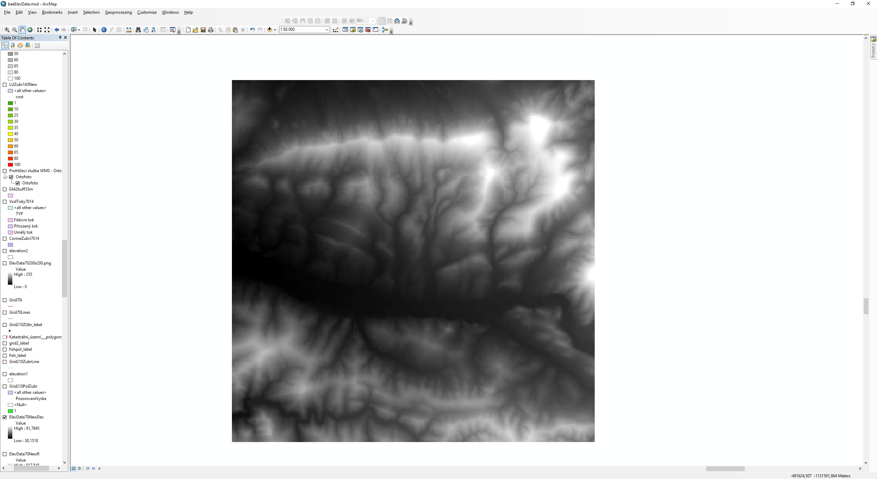

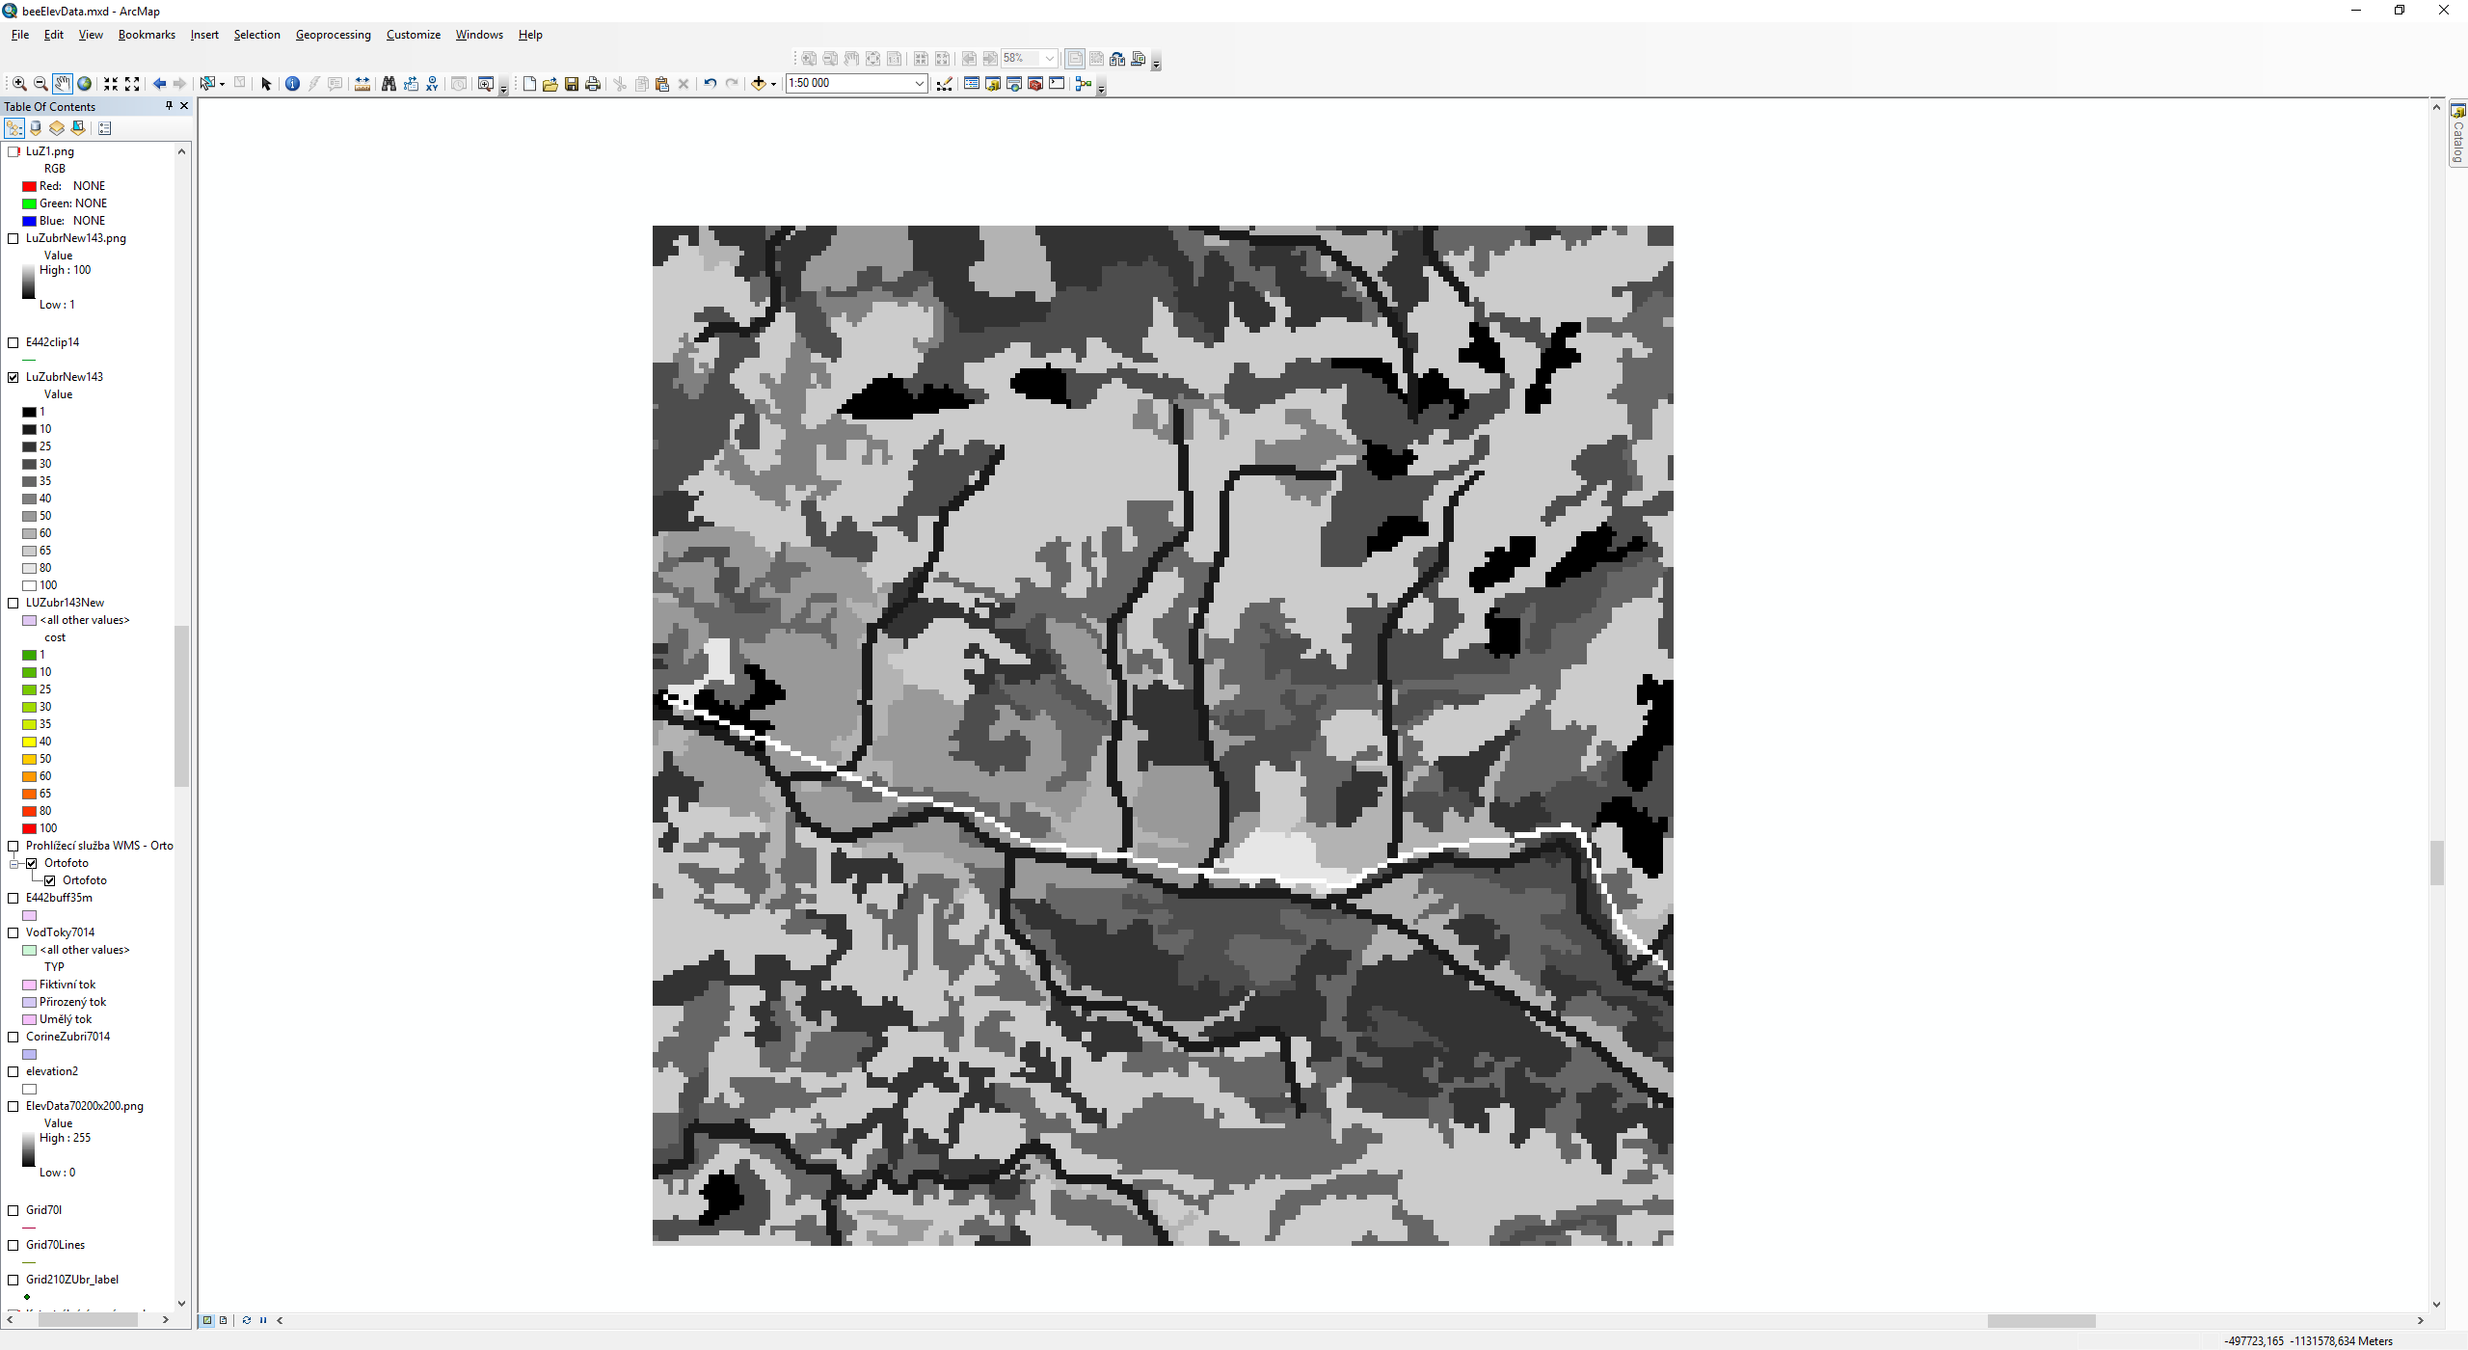

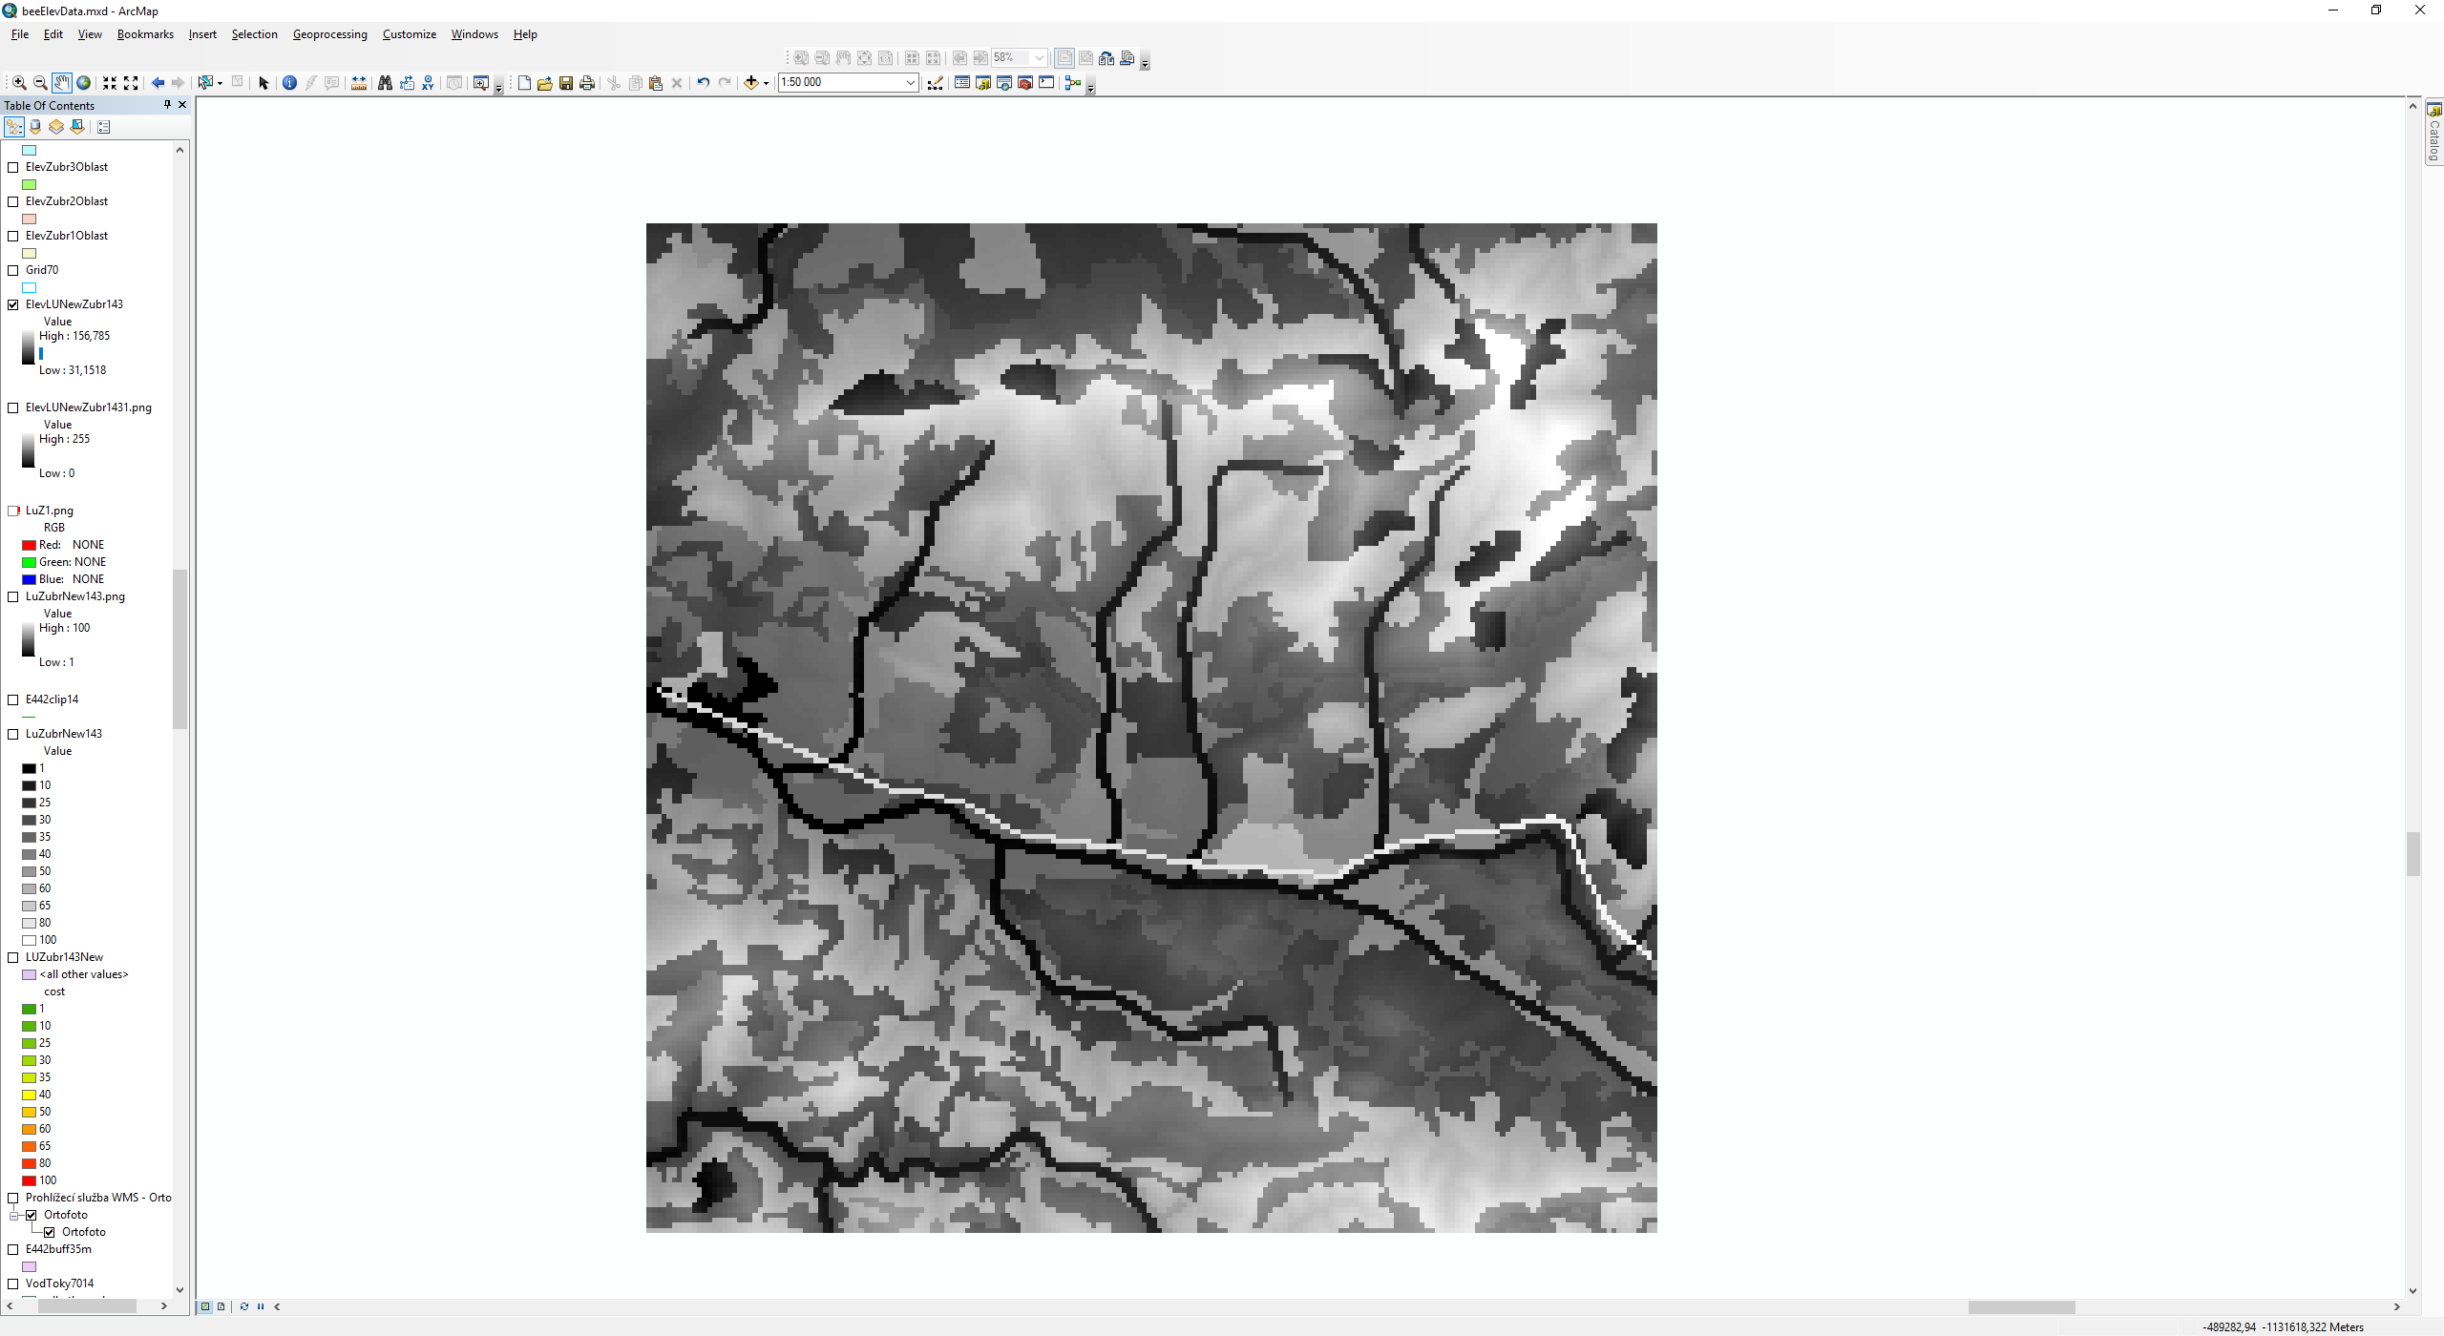

1. Vector based grid (fishnet) polygon (to save results in ArcGIS Desktop or similar software) and line (model input file). With same parameters as image data files (200 x 200 sectors with size of 70 m). The layers should be perfectly aligned. The file itself should be placed into includes folder of the project

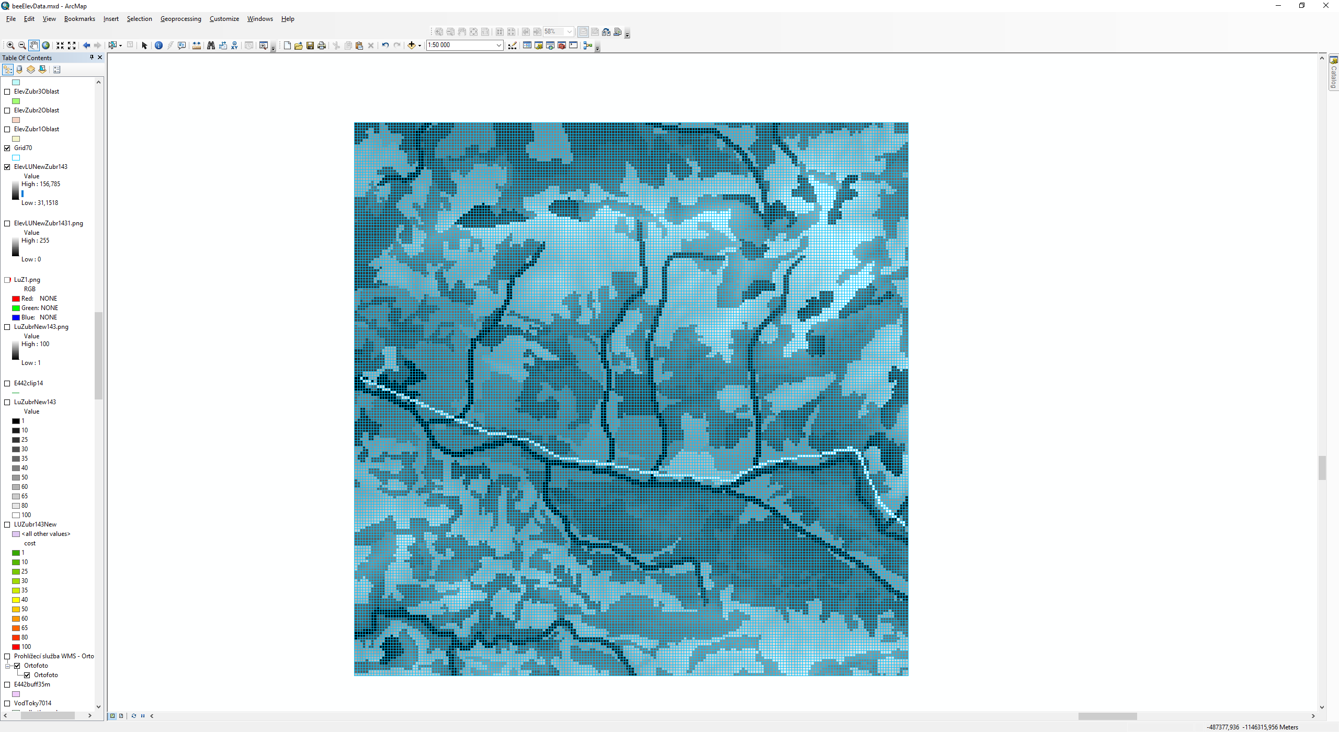 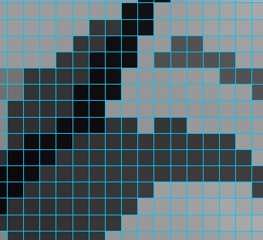

1. **Model GAMA Platform**
2. Model with examples files is imported through User Models -> Import GAMA Project and browse and select downloaded folder
3. Names and location of input files

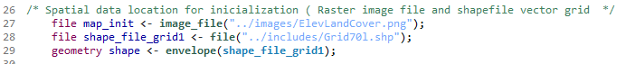

1. Location of hives (based on real location… To get model values -> Run the model( simulation perspective opens) Find the location in the model space, right click on the cell and follow procedure showed below. Then copy cords from location attribute and change them in the code
2. Infected hives are added through the same procedure as in C)… Change color_value attribute of cells with infected hives from zero to one
3. Size of modelled environment 200 x 200 by default same as the size of input file

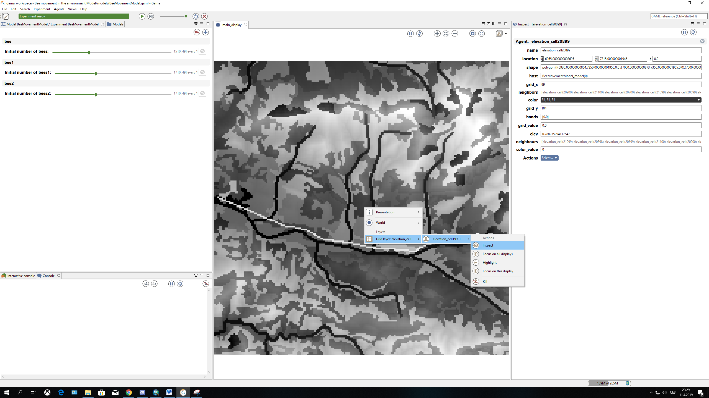



1. Maximum distance for bee is set to 7 km ( 100 cycles of 70 m cells), This can be changed: either through number of cycles or if the size of the cell is different

Result are saved as shapefile to folder results/ElevCor/ and name of the file. The number at the end of the name of the file should be changed before running the experiment. Otherwise result may be rewritten



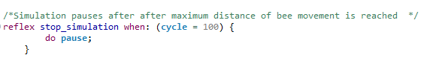

1. Initial location of bee each bee type (3x) . Values can be found in the simulation perspective. Same procedure as in C) attributes grid_x and grid_y







1. Bee movement behaviour. By default there is 20 % probability that bee chooses cell with higher resistance value. This can be changed under ( if flip (0.20)) for each type of bee

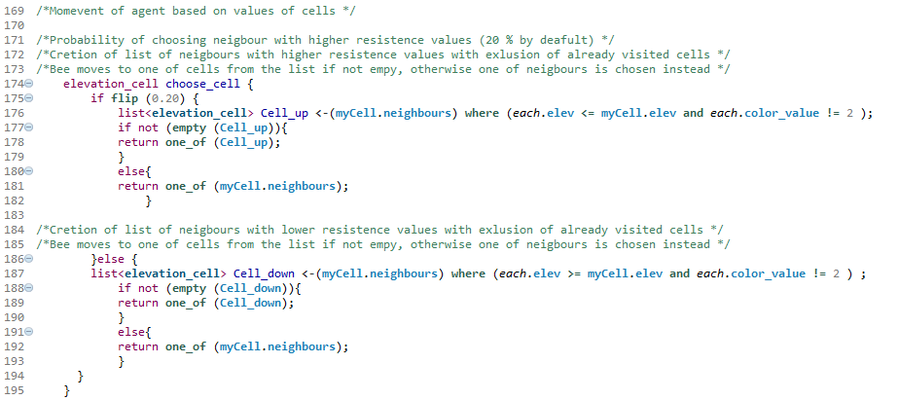





1. Creation of modelled environment with list of neighbours for movement and interaction



1. The number of bees can be changed in the code or through sliders in the simulation perspective (in this case experiment should be reloaded CTR +R) . Total number of bees should not exceed 49 (with the default resolution and size of modelled space) due to computation time.

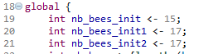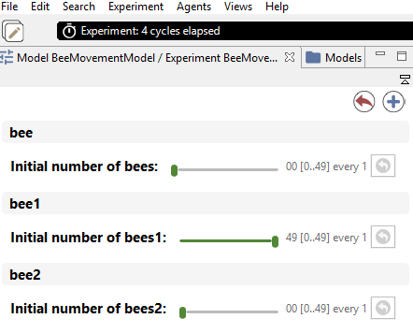

If the number of bees is changed the following conditions should be adjusted to correspond with the number of bees in the simulation

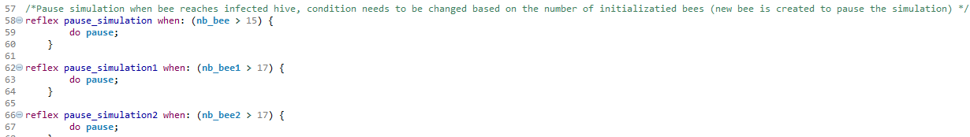

1. After the simulation ends a Snapshot with explored area may be created. The image is saved as PNG file under gama_workspace -> Bee movement in the environment Model -> models -> snapshots

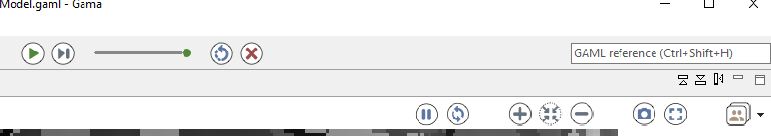

Or procedure using the created shapefile may be used instead to visualize and save all results in one file in GIS software as described below

The simulation should be run repeatedly (25 iterations were performed in the test experiment). After each iteration a snapshot can be taken or shapefile with result can be used (with number for each iteration e.g ElevLC1.shp, ElevLC2.shp…)

1. **Visualization and storage of data in GIS software**
2. The results of the model in shapefile format can be found in gama_workspace -> Bee movement in the environment Model -> results -> ElevCor -> name of the file



1. The results should be loaded into the GIS software together with the polygon fishnet created in 1b) (shapefile GRID70 in includes folder is provided as example)
2. Next visited sectors are selected as shown below and new layer may be created

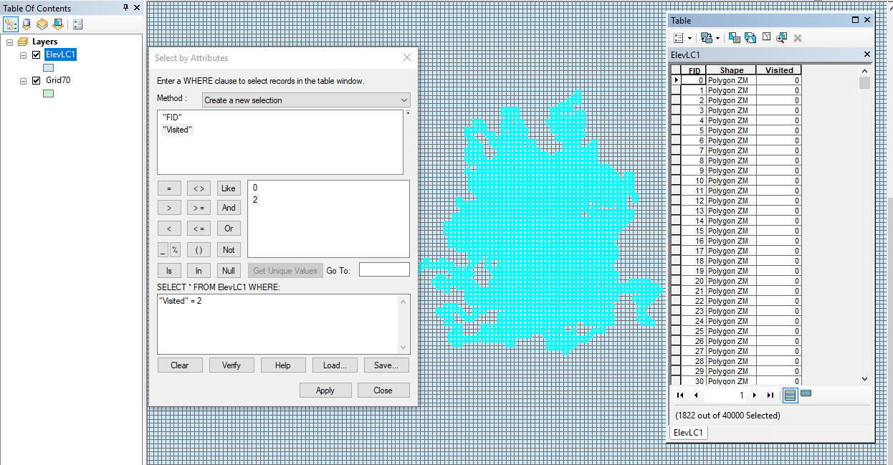

e)Next sectors from the polygon fishnet are selected as shown in the condition below

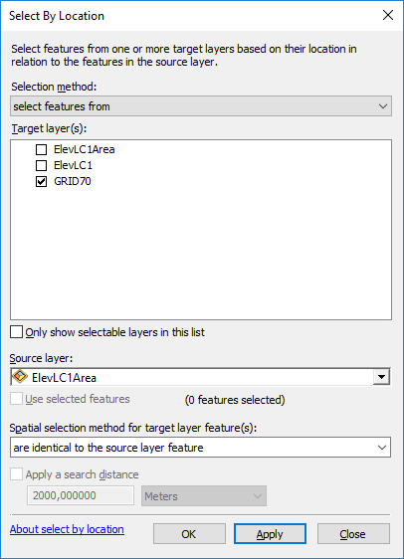

f)New field is added and with value 1 for the selected sectors

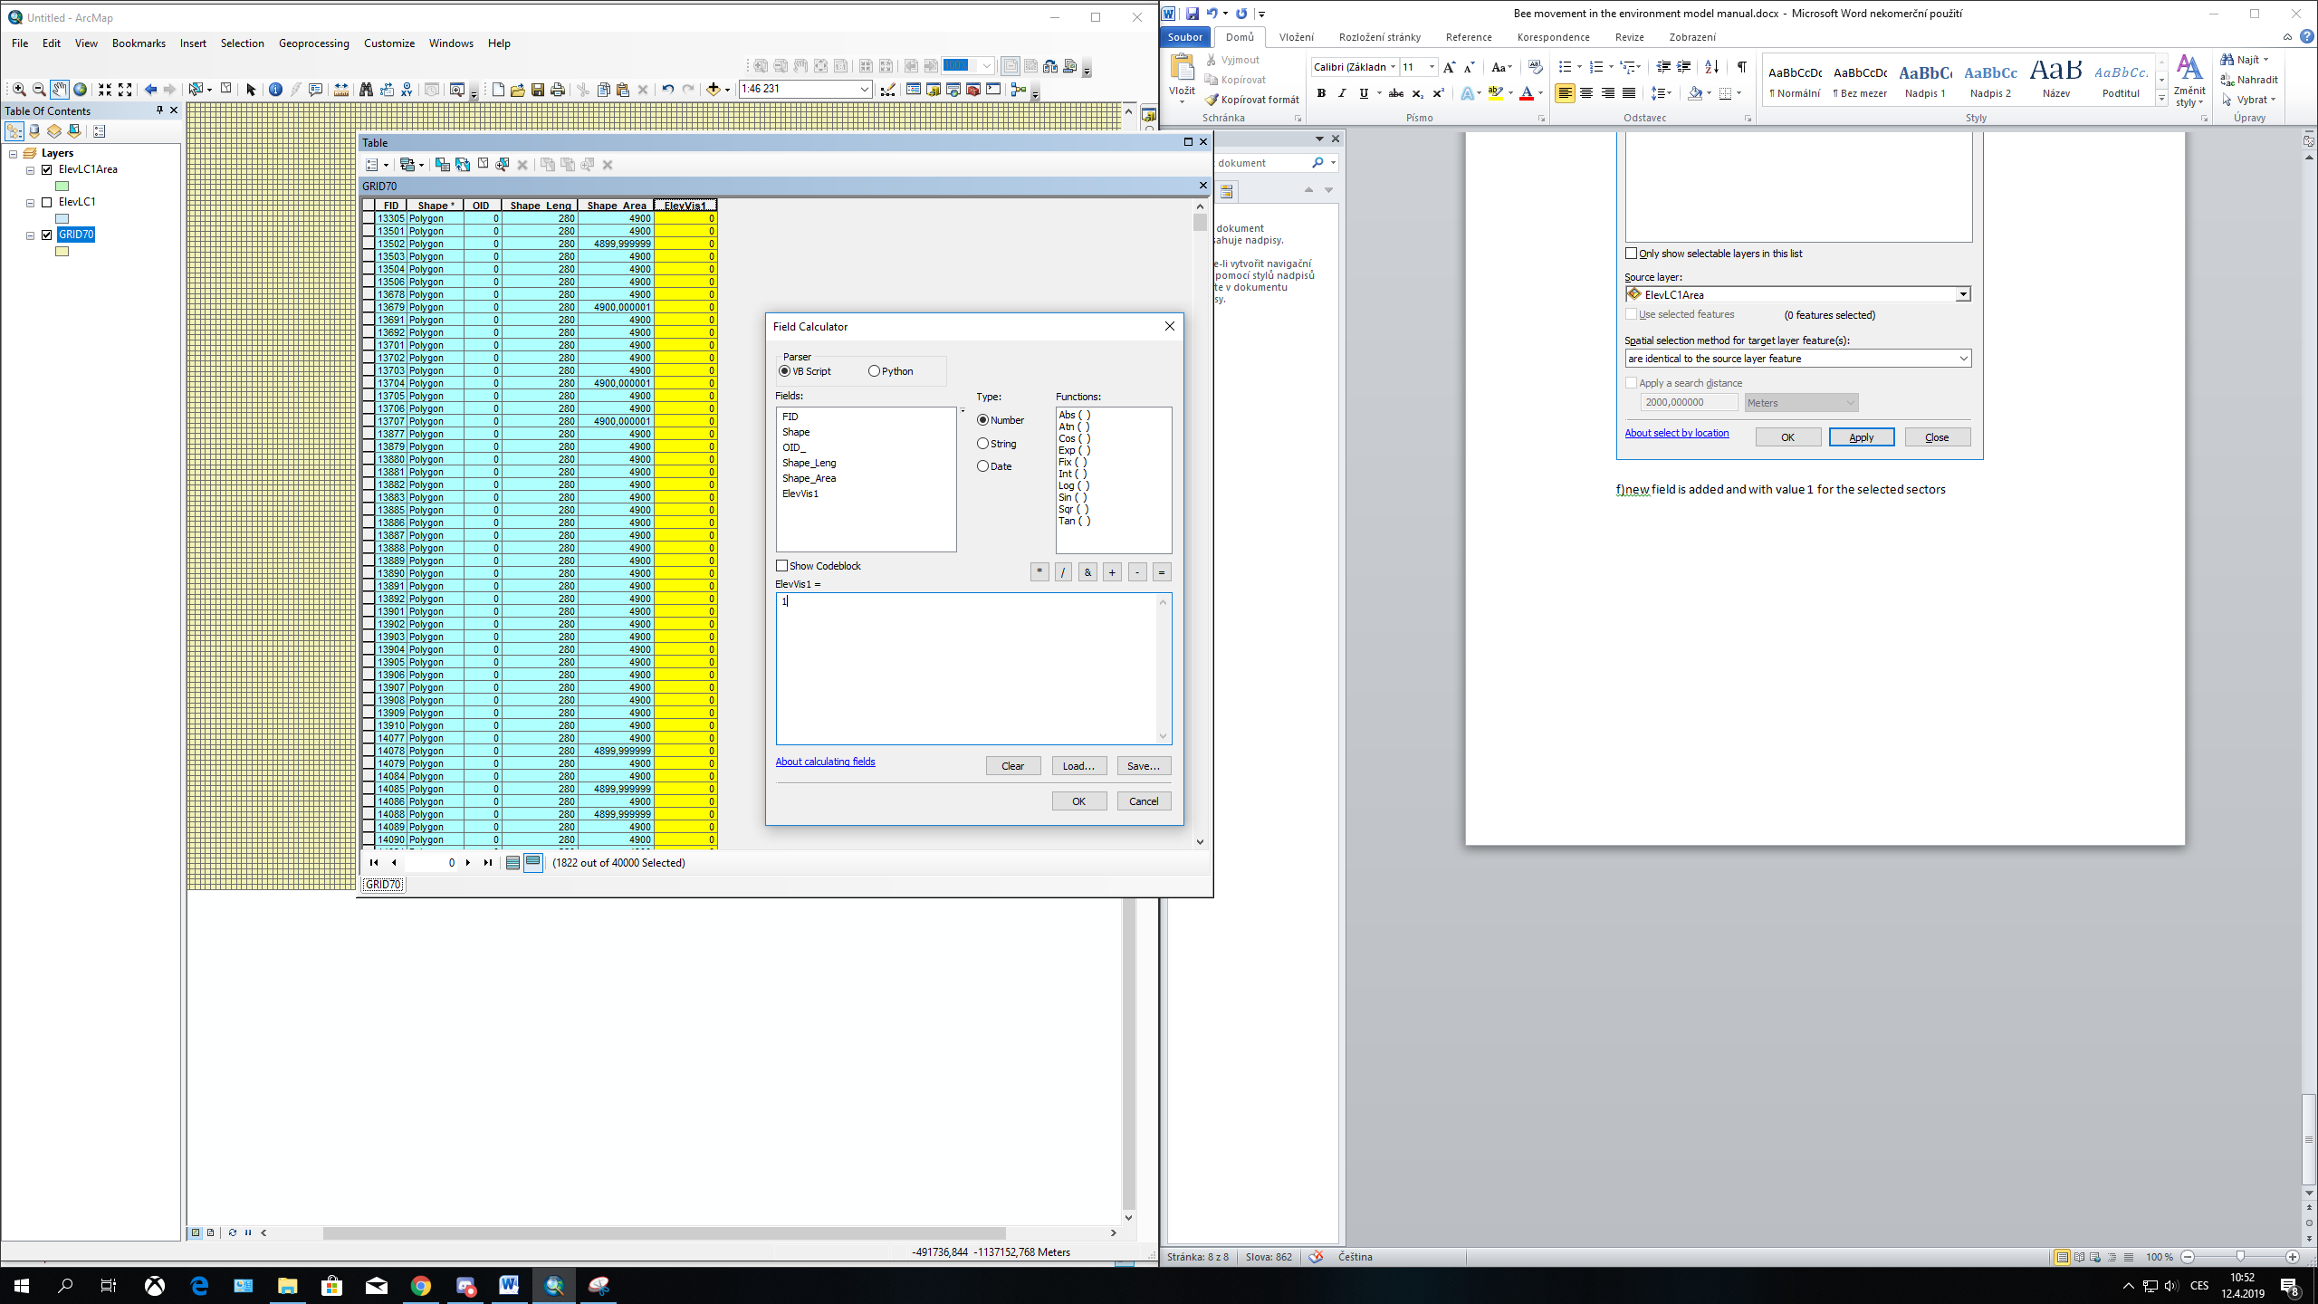

g) Steps 3b) to 3f) are repeated for each result. Finally all saved results ( 25 columns with ones and zeros) are counted, divided by number of results and multiplied by 100 to get percentage of intensity of visits per sector. The final result can look similar to the one shown below

Green color shows the intensity of visits of sectors.

Red are infected hives

In this example the bees will not be infected from AFB + hives localized in Veřovice. Though they may infect themselves through robbing in Vidče (low probability). Highest probability of infection is in the dark green sectors in Zubří

